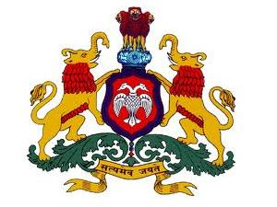

**BOARD OF TECHNICAL EDUCATION**

**GOVERNMENT OF KARNATAKA**

**B.L.D.E. ASSOCIATION’S**

**SHREE SANGANABASAVA MAHASWAMIJI POLYTECHNIC**



VIJAYAPUR – 586103

(Affiliated to BTE, Bangalore, Approved By AICTE, New Delhi)

DAILY LOG BOOK

SUBMITTED BY 6TH SEMESTER

RAHUL HALLI 507CS20005

UNDER THE GUIDENCE OF

**SHRI. B.D JOSHI**

DEPARTMENT OF COMPUTER SCIENCE & ENGINEERING

2022-2023